**LAB # 03**

**Task # 1: Login Page Application using Relative Layout.**

**Solution:**

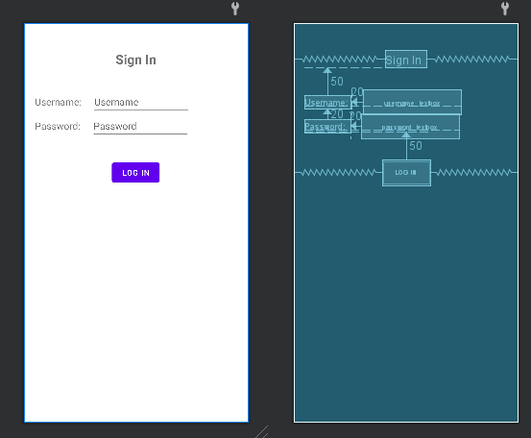

**Output:**

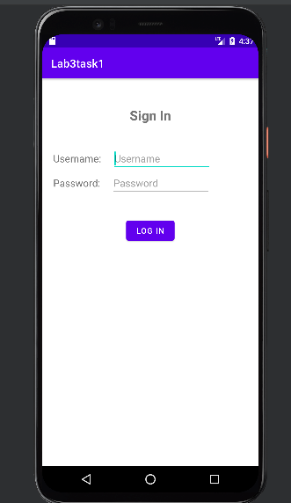

**Task # 2: Calculator Application using both Relative and Constraint Layout.**

**Solution:**

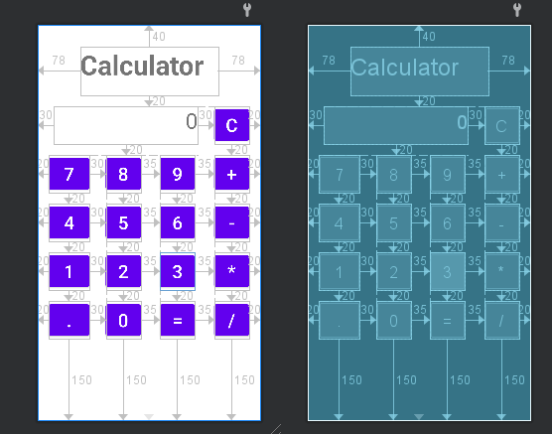

**Output:**

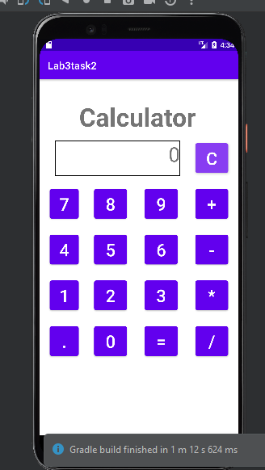

**Task # 3: Food Ordering Application using Constraint Layout.**

**Solution:**

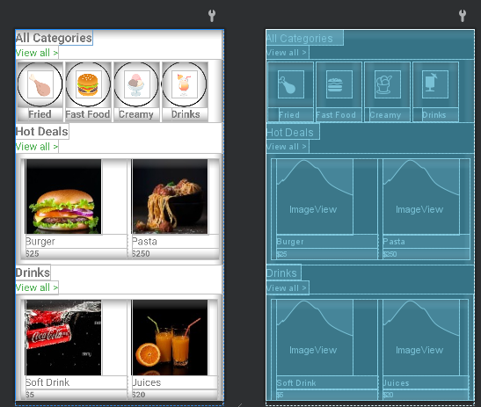

**Output:**

